Banagher College Notes (for week ending Fri Oct 18th 2019)
Junior Camogie:
Our Junior Camogie girls recorded their second win in the Leinster B Campaign when they came from behind to beat Coláiste Naomh Cormac 3-15 to 3-5 in Kilcormac on Wednesday October 16th. The team was, Molly McDermott , Patricia Kelly, Ellie Gohery, Eva Flannery, Amy Mannion, Kayla Earner(1-3,0-3fs), Caoimhe Darcy, Sinéad Hanamy(0-1), Labhaoise Glynn, Katie O Connell(0-5), Cathy Moran, Aoife O Regan(1-2),Emma Nevin(1-1) ,Mia Flannery(0-2), Amy Sullivan(0-1).
Subs:Erin Vaughan for Emma Nevin, Sophie James for Sinéad Hanamy, Cáit Hickey for Labhaoise Glynn, Holly Boylan for Mia Flannery and Eilish Naughton for Amy Mannion.
This team has remaining games v St Joseph’s Rochfortbridge(A) and Castlecomer C.S. (H).

First Aid:
We are very grateful to local First Responders Donal Moran, Damien Keenaghan and Jackie Duffy for delivering CPR training to our TY Students on “ National Restart The Heart Day” on Wednesday October 16th. Thank you to our three local volunteers who are providing an essential life saving service and creating life saving opportunities for our students into the future.

Senior Ladies Football:
Our Senior Ladies Footballers opened their Leinster D Campaign with a 4-9 to 3-5 win over Castlecomer C.S. in Castlecomer on Monday October 14th
Team: Aideen Lyons,Marie Clare Fogarty, Tiyana Hein Walsh, Emily Guinan, Eilish Naughton, Hannah Cannon, Rebecca McGarry, Labhaoise Glynn(1-4),Amy Leonard(0-1),Grace Butler(1-0),Cathy Moran(2-2), Róise McGarry(0-1),Ella Camon(0-1), Jessica Wynne Smith, Saoirse Flynn.

Subs Used: Abbie Graham,Caoimhe Darcy,Mia Flannery,Alannah Walsh Graham and Katie O Connell.
EU Code Week at Banagher College
This year saw Banagher College mark EU Code Week for the very first time. The TYs recently set up their first Coder Mojo Team (a branch of the wider TY Mojo Digital teams) to enter in the Department of Communications School Digital Champions initiative. Their aim is to increase participation and positivity around coding in the school. They decided to use EU Code Week to launch their campaign by promoting this international event, and particularly by running a series of ‘Introduction to Coding’ cross-curricular workshops for all First Years in the school. The three-hour workshops, which took place in the school’s new STEAM (Science Technology Engineering Arts Maths) room were a big success for the Coder Mojo team, as many of the First Years had a very enjoyable and fun first introduction to the world of coding, while others got a chance to build on their previous experience. The TY team have big plans to add to this success as they work towards their School Digital Champion goals in the year ahead. 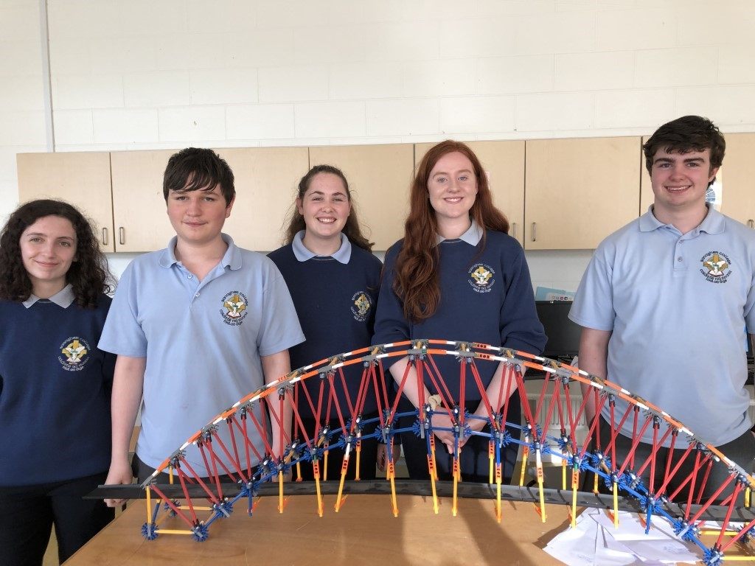
Members of the Banagher College School Digital Champion Coder Mojo team: (l-r: Lorna Kelly, Josh McDowell, Amy McGough, Leanne Mahon, Chris Rigney.)

